Lab 09 Gates
Introduction

AND Gate
A 2-input AND gate is constructed using RTL Resistor-transistor switches connected together as shown below with the inputs connected directly to the transistor bases. Both transistors must be saturated “ON” for an output at Q.
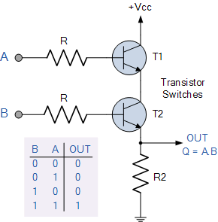

Commonly available AND gates include:
TTL Logic AND Gate CMOS Logic AND Gate
74LS08 Quad 2-input CD4081 Quad 2-input
74LS11 Triple 3-input CD4073 Triple 3-input
74LS21 Dual 4-input CD4082 Dual 4-input

7408 Quad 2-input AND Gate
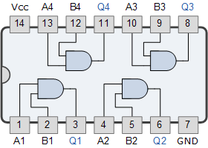

OR Gate
A 2-input inclusive OR can be constructed using RTL Resistor-transistor switches connected together as shown with the inputs connected directly to the transistor bases. Either transistor must be saturated “ON” for an output at Q.
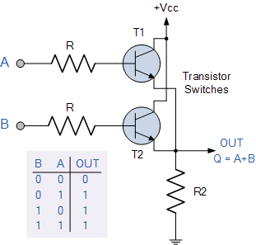

Multi-input OR Gate
Commonly available OR gate s include:
TTL Logic OR Gates CMOS Logic OR Gates
74LS32 Quad 2-input CD4071 Quad 2-input
CD4075 Triple 3-input
CD4072 Dual 4-input

7432 Quad 2-input Logic OR Gate
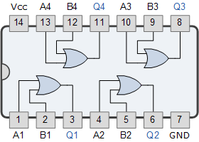

NOT Gate
A 2-input logic NOT gate can be constructed using a RTL Resistor-transistor switches as shown below with the input connected directly to the transistor base. The transistor must be saturated “ON” for an inverted output “OFF” at Q.
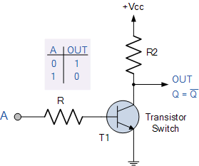

TTL Logic NOT Gates CMOS Logic NOT Gates
74LS04 Hex Inverting NOT Gate CD4009 Hex Inverting NOT Gate
74LS14 Hex Schmitt Inverting NOT Gate CD4069 Hex Inverting NOT Gate
74LS1004 Hex Inverting Drivers

7404 Logic NOT Gate or Inverter
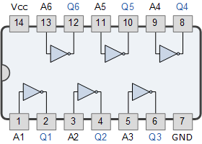

Problem 1. Using inverters, AND gates, and OR gates to simulate construct a XOR gate
An exclusive OR circuit gives a true output if the number of true instances is odd and gives false otherwise. A simple circuit diagram of an exclusive OR gate is 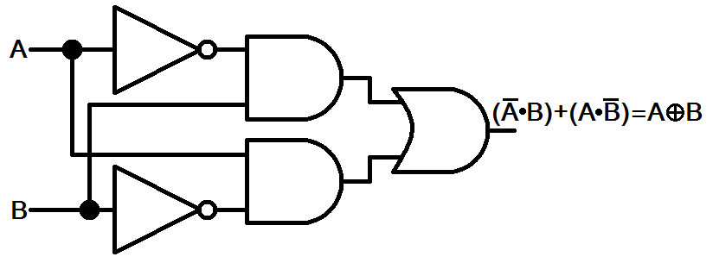
Figure 1: Exclusive OR
The truth table of an exclusive OR and exclusive NOR gate for two inputs is given in the table below,
A | B | XOR | XNOR
0 | 0 | 0 | 1
0 | 1 | 1 | 0
1 | 0 | 1 | 0
1 | 1 | 0 | 1

Hint: In the get new part window, type ‘7404’ to display a NOT gate available in PSPICE. From that list select a simple NOT gate as shown in the figure 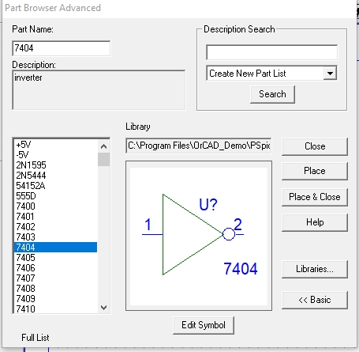
Placing NOT gate
Open the get new part window and type 7408, select the AND gate from the list given and then click on place & close as shown in the figure below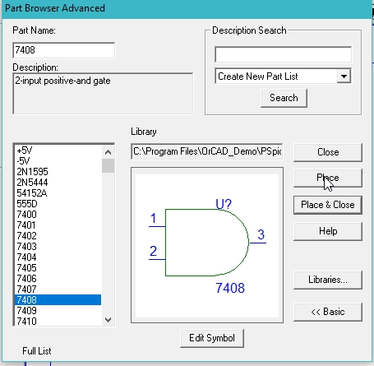
Placing AND gate
Open the get new part window and in the part name block type 7432, select the OR gate from the list given and then click on place & close as shown in the figure below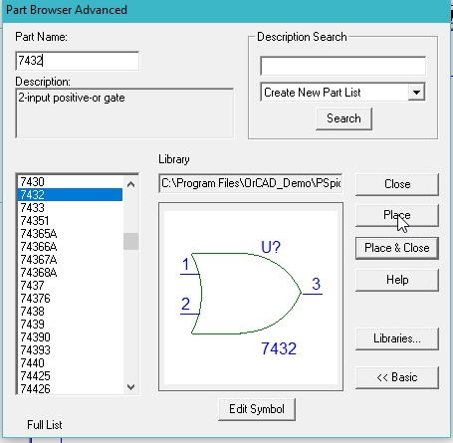
Placing OR gate
Place a ground, do the same again and in the part name type Dstm and select the digital source and then click on place & close as shown below,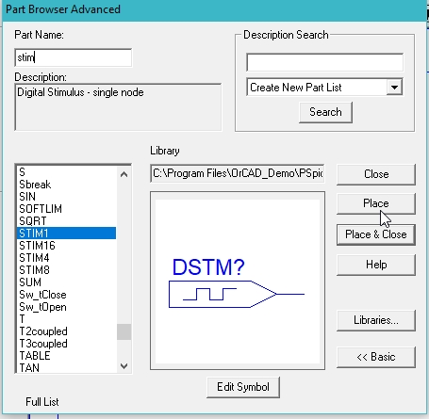
Placing digital source
The placed components in the schematic window are shown in the figure below,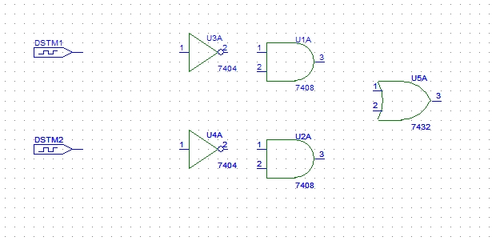
Placed components
- Connect all the components to complete the circuit diagram as shown in the figure below,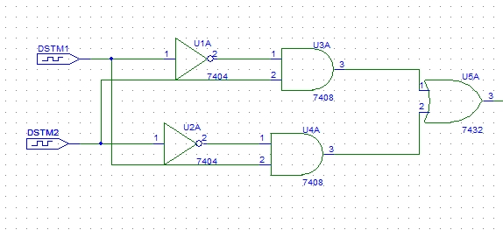
Complete block diagram
On the top of the schematic window, click on the Voltage/Level Marker button as shown in the figure below,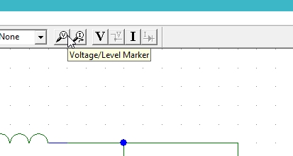
Figure 12: Voltage marker
Place Voltage Marker at the output and at the input nodes 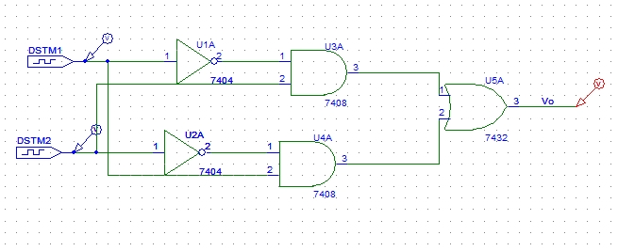
Placed voltage marker
If interested in checking the voltage on a specific wire, double click on the wire, type the name of the wire you want to label it with, as shown,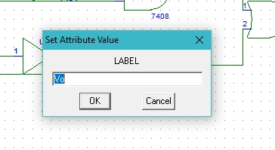
Labeling a wire
Set the attributes of the input digital supply. Double click on the dstm1 supply you connected in the circuit previously and set the input commands of the digital input system as shown in the figure below,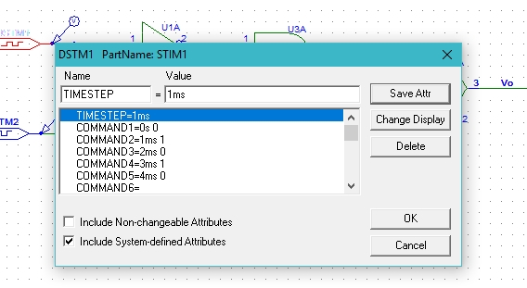
Input 1 attributes
The commands in the attributes window represents the value of the input at the corresponding time in the command before the space. The COMMAND1 = 0s 0 shows that at time 0s the value of the input dstm is 0 and the COMMAND2 = 1ms 1 shows the value updates to 1 at time 1 millisecond. Similar is the case with COMMAND5 = 4ms 0 that at 4 milliseconds the value of the input will be 0.

Set the attributes of the input digital supply. Double click on the dstm2 supply and set the input commands of the digital input system but these commands will not be same to the commands of input 1 as shown,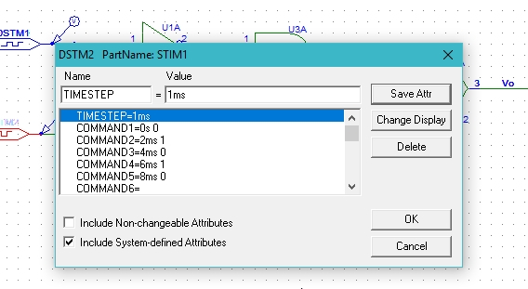
Attributes of input 2
These commands will update after one complete cycle of the input 1 signal. After the input value of the input 1 source changes from zero to one and then back to zero the input value of input source 2 only changes from zero to 1. These command are adjusted so in order to complete all the binary input combinations for two variable inputs as shown in the table below,
A | B
0 | 0
0 | 1
1 | 0
1 | 1
Click on analysis and then click on Setup as shown in the figure below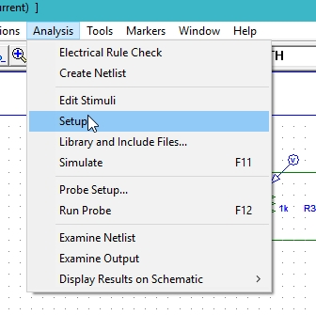
Simulation setup
A window will appear, click on the transient block on the window and adjust the properties of the window, refer to the figure 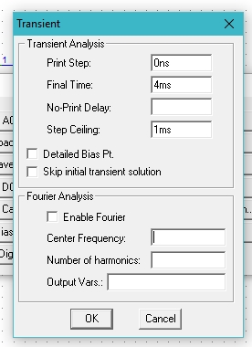
Transient response
Click on the analysis at the top bar of the schematic window and then click on simulate as shown in the figure,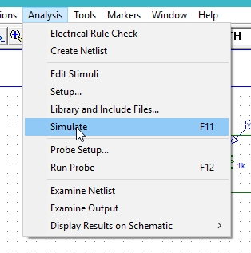
Simulation
A schematic window will show the voltage at the output wire and the input source as shown in the figure,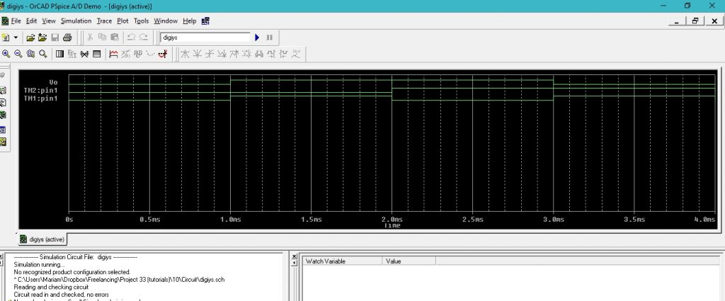
Output of simulation
Problem 2
Build and simulate the XNOR gate.

PreLab
Problem 1
Identify each of these logic gates by name, and complete their respective truth tables:
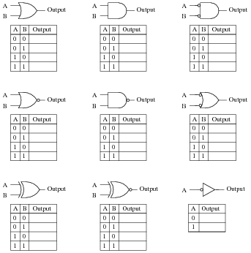
Problem 2
Suppose you needed a two-input AND gate, but happened to have an unused 3-input AND gate in one of the integrated circuits (“chips”) already in the system you were building. Of course, you could just add another IC containing 2-input AND gates, but it seems a shame to waste the 3-input gate already there.
Explain what you would need to do with the third input terminal on this gate in order to use it as a 2-input AND gate:
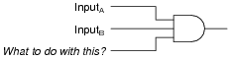

Now, explain what to do with each of the following gates’ third inputs, in order to use each of them as 2-input gates:
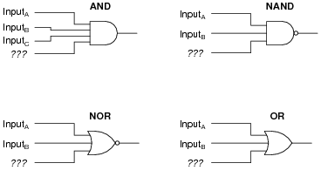

In each case, describe why your solution works.

