BJT Amplifier DC Biasing

Objective:
BJT transistors are the most widely used form of transistor used in general applications. The major application of BJT includes the amplifier circuit. In building an amplifier circuit, the transistor must be biased which this lab will introduce you to, the biasing of an amplifier.

Equipment Usage
For this lab, the following equipment will be used:
• Power supply
• Multi-meter
• Breadboard
• Oscilloscope
• NPN and PNP BJT

Background:
A BJT is a current amplification device, but current and voltage are directly related. Keep this in mind during your analysis of the circuit. The biasing circuit sets the base voltage, which in turn determines the transistors operating I-V curve. Figure 6-1 illustrates a common emitter biasing circuit.

Figure 6-1

Resistors R1 and R2 determine the base voltage required to set the base current.
BJT Biasing Lab Procedure for NPN
Given VCC = 10V, Rc = 1 kΩ, RE = 100 Ω, find R1 and R2 to set VCEQ = 5 V for the CE amplifier.

Set up the following circuit on your breadboard with VCC set at 10V and V_{bb} set at 0V:

Slowly, adjust Vbb until you measure the voltage at Vceq is 5V. As an example, Vbb is measured to be 1.188V and Ib is 47.25 μA (calculated from the voltage drop across Rb). Now, we can set up the biasing network, which consists of parallel combination of R1 and R2 as shown on the circuit below. Let the current thru R1 be ten times the current Ib i.e. 472.5 μA in our example.
Note: You may have to adjust resistor values slightly in the lab to bias correctly.
BJT Biasing Lab Procedure for PNP
Given VCC = -10V, Rc = 1 kΩ, RE = 100 Ω, find R1 and R2 to set VCEQ = -5 V for the CE
amplifier.

Set up the following circuit on your breadboard with VCC set at -10V and Vbb1 set at 0V:
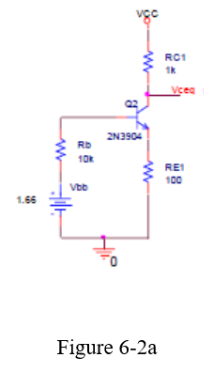

Figure 6-2a

Slowly, adjust Vbb1 until you measure the voltage at Vceq is -5V. As an example, Vbb1 is
measured as -1.247V and Ib is -25.29 μA (calculated from the voltage drop across Rb1).
Now, we can set up the biasing network, which consists of parallel combination of R7 and R8
as shown on the circuit below. Let the current thru R7 be ten times the current Ib i.e. 252.9 μA
in our example.

Prelab:
Analysis 1: Given VCC = 10V, Rc = 1 kΩ, Re=100Ω, β = 100, find R1and R2 to set VCEQ = 5 for NPN and VCEQ = -5V for PNP for the CE biasing circuit shown in Figure 3. Simulate quiescent, (VCEQ), point changes when Beta (β) assumes the value of 50, 100, and 150 for both NPN and PNP transistor circuits. What happens to the voltage VCEQ as Beta changes?
For taking Vbb we need to simulate figure 6-2a
Formula for R1 and R2 are.
$$R_{1}=\frac{Vcc-Vbb}{Vcc*Ib}$$
$$R_{2}=\frac{R1*Vbb}{Vcc-Vbb}$$

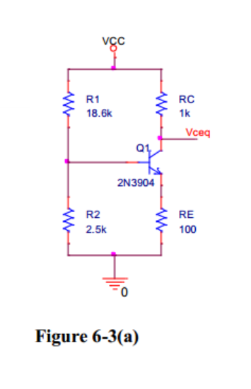

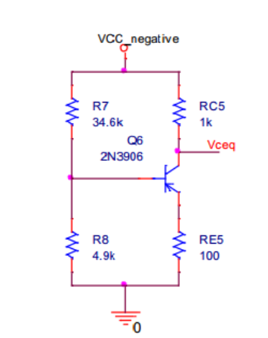
Analysis 2: Given VCC = 10V, RE = 1250 Ω, Rc = 1 kΩ, β = 100, find R1 and R2 to set VCEQ = 5V for NPN and VCEQ = -5V for PNP for the CC biasing circuit shown in Figure 6-4(a,b). Simulate quiescent, (VCEQ), point changes when Beta (β) assumes the value of 50, 100, and 150 for both NPN and PNP transistor circuits. What happens to the voltage VCEQ as Beta changes?

For taking Vbb we need to simulate figure 6-2a
Formula for R1 and R2 are.
$$R_{1}=\frac{Vcc-Vbb}{Vcc*Ib}$$
$$R_{2}=\frac{R1*Vbb}{Vcc-Vbb}$$

Rbb = Vcc * R2 / (R1 + R2)

Ib
Ic
VCEQ
Beta

